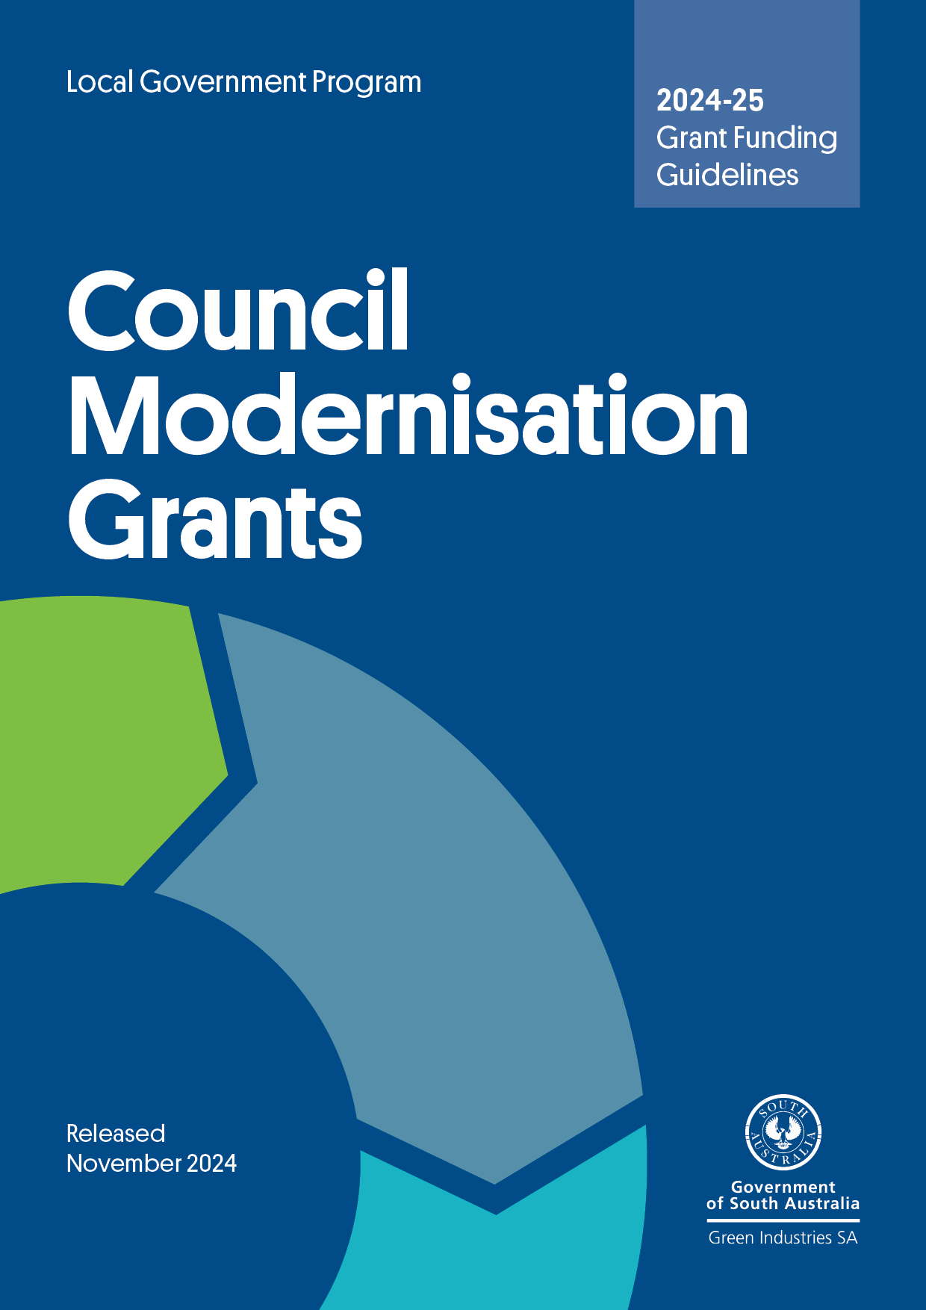

Contents
Submitting your application 3
About Green Industries SA 3
South Australia’s Waste Strategy 3
Waste management hierarchy and circular economy 4
Program overview 4
Funding available 5
Matching the Council Modernisation Grant 5
Eligibility and priority areas 5
Ineligible activities 8
Eligibility criteria 9
Assessment criteria 9
Access to intellectual property 10
Funding agreement 11
Reporting 11

Acknowledgment of Country
GISA acknowledges and respects the Traditional Custodians whose ancestral lands we live and work upon, and pays respect to their Elders past, present and emerging.

We acknowledge and respect their deep spiritual connections, and the relationship that Aboriginal and Torres Strait Islander people have to Country.

We extend our respect to all Aboriginal and Torres Strait Islander peoples and their nations in South Australia, and across Australia.

Submitting your application

All applications must:
- use the form attached to these guidelines
- be submitted with a signed declaration
- be no more than 20 pages, and no more than 10MB (including attachments)
- be submitted electronically (Microsoft Word file) to justin.lang@sa.gov.au by 5pm, Friday 13 December 2024, with the subject heading ‘Council Modernisation Grants – application’.

Further information
Contact Manager, Local Government and Infrastructure Justin Lang on (08) 8429 8416 or at justin.lang@sa.gov.au.

About Green Industries SA
Green Industries SA (GISA) is an enabler and driver of change, supporting the development of the circular economy through diverse collaborations which improve productivity, resilience, resource efficiency and the environment.

GISA works to transform how South Australians use and value resources, and the agency’s objectives under the Green Industries SA Act 2004 are to:
- promote waste management practices that, as far as possible, eliminate waste or its consignment to landfill
- promote innovation and business activity in the waste management, resource recovery and green industry sectors, recognising these areas present valuable opportunities to contribute to the state’s economic growth.

Learn more about GISA.

South Australia’s Waste Strategy
The Council Modernisation Grants Program supports implementation of South Australia’s Waste Strategy 2020-2025. The strategy outlines actions that can contribute to a more circular economy in South Australia through:
- a clearly articulated policy and legislative framework that gives a solid platform for investment decisions and a stable and efficient market
- supporting innovation and commercialisation
- education, advocacy and awareness to support behavioural change in the way waste and resources are managed
- applying the waste management hierarchy consistently with the principles of ecologically sustainable development.

Waste management hierarchy and circular economy
South Australia’s Waste Strategy 2020-25 is underpinned by the internationally recognised waste management hierarchy, which is a guiding principle of the Green Industries SA Act 2004. Its efforts focus on the highest levels of the hierarchy considering social, environmental and economic practicalities. A transition to a circular economy is also a priority and a guiding focus for the strategy.
The Council Modernisation Grants Program emphasises:
- the higher rungs of the waste management hierarchy – avoid, reduce, reuse, and recycle – where unnecessary use of materials is avoided or reduce, materials are separated as close as possible to their point of generation, and safely used for their highest order purpose
- the principles of a circular economy – reduced reliance on virgin materials by keeping materials circulating in the economy for as long as possible, at their highest value use, and thereby reducing waste and pollution, and harm to the environment.

Program overview
The purpose of the Council Modernisation Grants Program is to encourage South Australia’s councils to improve waste management and recycling services through the introduction of innovative measures, and increase implementation of circular economy principles. The modernisation measures should result in operational efficiencies, improved customer service and economic development benefits for the community.

Since 2005 GISA, formerly Zero Waste SA, has funded metropolitan and regional councils to implement improved collection systems for residents. There has been increased emphasis on diversion from landfill using better performing kerbside systems in tandem with other initiatives, such as investment in education, regional planning, research and development, and infrastructure. These programs have been successful in promoting safe, high performance recycling systems to South Australian councils. However, data shows that the overall average three-bin recovery rate is below South Australia’s Waste Strategy 2020-25 metropolitan municipal solid waste diversion target of 60% by 2023 (including from high performing bin systems) and 70% by 2025, meaning further steps need to be taken to achieve the 2025 target.

Continuing with a ‘business as usual’ approach would limit our ability to maintain South Australia’s exemplar leadership in the waste management and recycling sector and generate economic activity. There is an imperative to encourage innovation and best practice in the sector. Through modernisation, we have the potential to create opportunities for new businesses to improve competitiveness and generate employment growth. Innovation can drive modernisation through investment in technology and broader market testing, researching and piloting of all aspects of circular business models and practices, waste management and resource recovery service provision, capacity and capability building. In doing so, South Australian councils can expect to reduce service costs, improve operational performance, and increase householder satisfaction and engagement.

Funding available
Applications for grants from $15,000 to a maximum of $100,000 (excluding GST) per project are invited. Priority will be given to applications which have a budget already allocated.

All applicants must:
- contribute at least 50% of total project costs (that is, match the grant funding) from sources other than the South Australian and Australian governments. In-kind contributions cannot be counted towards the matched 50% contribution.
- have projects completed within 2 years of the grant being offered. Projects which have a completion date before 30 June 2026 will be given priority.

Collaborative applications with project partners such as other industry organisations, associations and representatives from targeted market segments are welcomed. Applicants unsure about the eligibility of the proposed project should contact Justin Lang on (08) 8429 8416 to discuss the matter further.

Matching the Council Modernisation Grant
The grants contribute a maximum of 50% of eligible project costs, up to the maximum listed above. Applicants should be able to demonstrate at a minimum matched funding from other sources (excluding the South Australian Government). Applicants should not include ‘in-kind’ (non-financial) payments as matching funds.

Eligibility and priority areas
The funding is available to all South Australian councils and subsidiaries under the Local Government Act 1999 that manage waste and recycling services (including organics) for residential and small business ratepayers.
This includes:
- waste and recyclables collected through kerbside collected bins
- hard waste
- waste and recyclables collected at drop-off facilities
- public place recycling
- council-operated commercial collection services.

Priority areas which are eligible for funding under this program are identified below. Other proposals which meet the program’s objectives relating to innovation and economic development are encouraged. It is expected that applications will include an assessment of community impact and/or consultation with other stakeholders, such as waste and recycling processing facilities.

Maximising collection of food waste through kerbside systems
Food waste makes up 40% of household residual waste (waste left over after recyclables are removed) and up to 22% of total household kerbside collected material. At around 3.3 kg per household of food waste presented for kerbside collection each week, it is one of the largest components of collected household waste in metropolitan Adelaide, impacting on councils’ landfill costs.

All metropolitan Adelaide councils allow food waste to be placed in householders’ kerbside organics bins, however the efficacy of this approach varies between councils with differing collection frequencies, provision of kitchen caddies and accessibility of compostable liners.

Pilot projects to increase food waste diversion are eligible for funding as follows:
- Pilots across a geographic area to trial and evaluate models of alternative bin and collection systems to encourage optimum uptake. This may include alternate bin collection frequencies where residents can select the frequency of their organics collection service/suite of services. This project type will be a priority of this round of funding.
Applicants are encouraged to refer to the SA Better Practice Guide – Sustainable Kerbside Services.
- Feedback loops to households on how to minimise contamination and maximise waste diversion (may include bin tagging/technological solutions).

Note that trials should be for a minimum 12-month consecutive period with a view to continuing a service.

Refer to GISA’s Kerbside Food Waste System Grants for financial support for the rollout of universal, area-wide ‘high-performing food waste collection systems’ incorporating a kitchen container/caddy and compostable bags for diversion through kerbside green organics bins. Where required, funding for additional kerbside organics bins may be sought, but assessment will consider competitive contract pricing and leveraging of funding.

Note: Section 10(2) of the Environment Protection (Waste to Resources) Policy 2010 requires metropolitan councils to provide a weekly general kerbside waste collection service (other than for recyclable waste or vegetative matter) in respect of residential premises within its area.

Market research to assess ratepayer attitudes
Projects may include:
- market research to assess community attitudes relating to different collection service frequencies, and in support of proposed pilots or other modernisation initiatives
- research into the use of kitchen caddy systems in council areas where area-wide food waste systems have been implemented, to evaluate behaviour and acceptance and influence the design of financial support programs to enhance or maintain systems
- research to support the updating of regional waste strategies (see section below)
- research to assess ratepayer views on ways to provide feedback on use of waste and recycling services, such as providing itemised information in rate notices.

Regional waste management plan updates
Regional waste management plans identify workable, efficient and cost-effective solutions for managing rural wastes.

Recognising the challenges of waste management in regional South Australia, GISA has supported regional councils to collaborate in the development of waste management plans since 2003–04. Many of these plans require updating to ensure these are ‘fit for purpose’ and provide future direction for improved efficiencies in regional services.

Plans should consider South Australia’s Waste and Resource Recovery Infrastructure Plan, which provides guidance for the future infrastructure planning and investment in the waste sector. Importantly, this plan identifies potential future infrastructure needs and investment opportunities to inform investment and grant funding decisions.

Note: refer to the Regional Transport Subsidies Program for information on transport cost relief.

Regional waste management/circular economy coordinators
Seed funding of up to 33% will be available per annum, for a maximum of 2 years, to support joint-funded Regional Coordinator positions. To be eligible regions must submit a project on behalf of 3 or more councils to progress waste management and/or circular economy initiatives for the region.

Applications will require:
- details of other funding committed/to be provided from a minimum of at least 3 councils (may include additional sources of funding such as regional development organisations)
- a minimum contract term of 2 years for the coordinator role
- details of hours to be worked (FTE) by the incumbent
- a work plan of the projects to be progressed by the incumbent, which could include outcome-based activities, such as:
  - community education activities
  - waste contracts and freight related matters
  - progressing resource recovery facility or circular economy developments.

Note that funds may be provided 3 monthly in advance. A condition of the funding will require the coordinator to be hosted within a Regional Local Government Association or Regional Development Board office, and be employed by one of the partner councils, the RLGA or RDA. Funds will not be approved for the engagement of consultants.

Public place recycling stations
Access to public place organic bin systems is increasingly important as South Australia transitions from single-use plastic to compostable takeaway products.

Previous audits undertaken of public place bins in metropolitan Adelaide indicated that, with the exception of containers covered under the Container Deposit Scheme (CDS), minimal uncontaminated recyclable products are found in public place bins.

South Australian councils are invited to apply for matched funding for the introduction of public place bin station infrastructure with supporting visual cues aligning with Which Bin. Stations will be required to include at a minimum a public place organic bin, CDS container collection infrastructure (in the form of a bin or collection racks), and a bin for residual waste.

Note that matched funding does not include bin collection and processing costs.

Using technology to innovate
South Australia’s councils are invited to consider how technological innovation can be developed and applied to their waste management and resource recovery services. In doing so, councils should expect more efficient and effective operational performance and better environmental, social, and economic outcomes.

Other eligible projects
- Review/detection of contamination (at time of collection), bin-tagging and education of householders to inform potential solutions.
- Projects which improve source separation and kerbside performance particularly in regard to the quality and volume of kerbside organics and comingled materials (or reduce residual waste yields). Innovative bin systems (such as further separation of streams/additional streams offered to residents’ place-based solutions such as systems that encourage residents to utilise community drop-off facilities for aggregation of recyclables).
- Education as part of a pilot program (bin kerbside collected system pilots should incorporate Which bin household education resources).

Ineligible activities
Grant funds will not be available for:

- retrospective projects (to be eligible, projects must start after the application closing date, 13 December 2024)
- projects targeting:
- energy from waste outcomes
- hazardous waste kerbside collections in metropolitan Adelaide
- ‘stand-alone’ education and market research (unless part of a pilot project)
- projects which are eligible for funding or support under other South Australian government programs such as:
- Kerbside Food Waste System Grants
- Recycling or Circular Infrastructure Grants
- Which bin Household Education Program (GISA assistance available to councils).

Eligibility criteria
Green Industries SA has the discretion to not consider incomplete applications. The following criteria in your application must be assessed as sufficient for the application to be regarded as eligible for potential grant funding.

Capacity to modernise council waste and recycling services for better circularity
How the project will achieve better outcomes, such as:
- economic development, for example support for business development, market development, supply chain benefits and employment growth
- environmental benefits, for example increased quantity and quality of materials collected for recycling or reuse, and reduction in waste to landfill
- service delivery/operational efficiencies including reduced costs for council
- community – improved customer satisfaction and engagement; contribution to social wellbeing.

Project Management
Capability and capacity to manage the project is demonstrated through adequate market research, staff experience, risk assessment, and appropriate evaluation of the project.

Timing
Demonstrate in the budget a timeframe for each step in the project process. Preference will be given to projects that can be completed/commissioned within 2 years from offer of grant.

Assessment criteria
Applications that meet the eligibility criteria will be assessed against the following criteria.
Benefits of the project
- The improvements in municipal services such as collection efficiency, cost effectiveness, customer service, community impact/support and environmentally responsible waste management and resource recovery practices.
- The potential for the project to be scaled for wider uptake across the sector with learning from all intellectual property shared through case studies and presentations.
- Contribution of the project to enable a more circular economy for South Australia.

Project viability
A business case which demonstrates the initiative will result in or contribute to:
- economic development benefits
- reduced costs and/or more efficient and effective services
- improved access to public place recycling.

Contribution to the circular economy/waste management hierarchy
Fostering local economic activity that:
- reduces emissions and waste
- helps achieve economic development objectives
- promotes activities at the highest levels of the waste management hierarchy – where materials are used for their highest order purpose.

Value for money
The extent that grant monies are leveraged with other funding and whether there is an existing budget allocation for the initiative.

Access to intellectual property
Applicants must be able to demonstrate they have access to any intellectual property necessary to carry out the project. It is expected that in most cases there would be dual ownership of any intellectual property resulting from the project.

A condition of funding is that all intellectual property, reports, findings and outcomes will be shared to benefit the broader sector.

Privacy and commercial-in-confidence considerations
All applications will be treated as commercial-in-confidence. GISA reserves the right to include third party evaluations as part of the assessment process and has the ultimate discretion in relation to publicity for successful applications. Applicants are not permitted to publicise their projects without the approval in the first instance of GISA.

Insurance
For the duration of the project, successful applicants must maintain workers compensation insurance, public liability insurance for a minimum of $1 million per claim and personal accident insurance of $100,000 per participant.

Assessment process
- All applicants will be notified by the agency within 2 weeks of the submission date to confirm receipt of their proposals.
- Applications will be reviewed by a panel comprising GISA personnel and external specialists. The panel will assess all eligible applications against the assessment criteria.
- If required, additional written information may be requested from the applicant to assist with the assessment.
- The panel will recommend projects to be funded and funding amounts to the Board of Green Industries SA for decision.

Funding agreement
Successful applicants will be required to enter into a funding agreement with GISA. This agreement will set out the terms of the grant, conditions, payment schedules, project timing, key performance indicators, reporting requirements and other matters.

All required approvals, such as a council resolution, are to be provided within 3 months of the initial notification of the success of the application.

GISA must be acknowledged in all media and promotional activities relating to the project; the statement ‘this project has been funded by Green Industries SA’ or similar, would satisfy this requirement. Additional assistance may be provided where councils use the Which Bin brand. Copies of completed education materials are to be provided to GISA.

Reporting
GISA requires successful applicants to provide regular reports on the funded project. The reporting will be determined on a case-by-case basis. Reporting and payment milestones will be agreed with the applicant before funding is offered and included in funding agreements.

Green Industries SA, South Australia’s Kerbside Waste Performance (state & regional report) 2021-22, 2023

